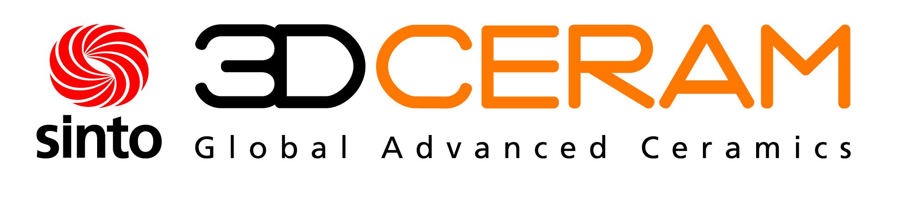

Press Release
Limoges, France, March 2018

New Generation of Hybrid Printers for Multi-Material Ceramics Production
(Hall 5 / Stand A16)

3DCeram Sinto, the leader in ceramics 3D-printing technology (SLA) has developed with its team of experts, specialized in ceramics, a new turnkey solution:
• sales of CERAMAKER printing lines
• consumables (3DMIX) pastes made on demand or standard
• all associated services (training, hot line, optimization design, maintenance and performance packs, etc.).
Today, 3DCeram Sinto is also marketing a new generation of hybrid 3D-printers that combine several 3D-printing technologies (inkjet, nozzle jetting or powder bed associated to SLA). These printers produce parts made of different types of ceramic or a combination of ceramic and metal (semiconductor for example).
3DCeram will present at ceramitec a new concept of automatic lines which will reduce manpower, increase efficiency and yield of the printing factory. This innovative turnkey line will integrate the CERAMAKER printer, a new generation of a dual kiln (debinding and sintering) as well as cleaning hood and automatic handling of 3DMIX and products.
Ceramic 3D-printing will enter Industry 4.0 with this innovative 3DCeram Sinto offer.
3DCeram Sinto and DORST Technologies/DE leverage their expertise in an innovative partnership in the ceramic market. With this agreement, 3DCeram Sinto, a leading additive manufacturer of technical ceramic products, will expand its global sales presence, and DORST Technologies will widen its portfolio by accessing the latest innovation in Additive Manufacturing. On Tuesday, 10 April 2018, at 5 p.m., the two companies will give a Apero reception at the booth of CERAMIC APPLICATIONS to celebrate the new partnership.

(1709 Characters)

Figure caption
(3DCeram_Sinto_1_2018-3.tif)
Multi-material print heads

Press contact
3DCeram Sinto, Richard Gaignon, richard.gaignon@3dceram.com
CERAMIC APPLICATIONS, Karin Scharrer, k.scharrer@goeller-verlag.de

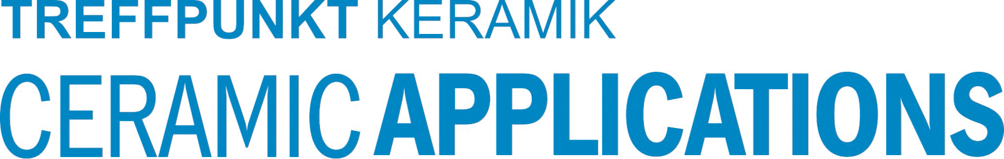

Hannover Messe, Hall 5, Stand A16

