Press Release
Plochingen, Germany, March 2018

Material for Industry, Architecture, Design and Technology – Transparent and Extremely Robust: Perlucor
(Hall 5 / Stand A16)

Its exceptional properties are what make the high-purity ceramic material Perlucor suitable for virtually universal use: The transparent material has been perfected as a solution in mechanical, chemical, thermal and aesthetic terms for extreme transparent applications.

The transparent ceramic is resistant to highly concentrated acids and alkalis. With a relative transparency of more than 90 %, Perlucor offers an attractive alternative to glass wherever glass meets its limits in practical applications. The material has three to four times the hardness and strength of conventional glass. On the Mohs scale it has a hardness of 8 to 9 – which makes it exceptionally resistant to high mechanical stress and scratches. This high-performance ceramic also has higher thermal resilience by a factor of three, so it is suitable for use in temperatures up to 1600 °C. With a high refractive index of 1,72, it can also be used for the miniaturisation of optical lenses and elements.

Interesting material for architects
Transparent surfaces such as glass staircases and walk-on light well panels, rooflights and glass floors are subject to considerable mechanical loads, but are also expected to be long-lasting and provide reliable service. This is where Perlucor comes into its own, for example in the DASAR PREMIUM lighting series from SLV, where it provides protection for the cover glass. The glass elements remain permanently transparent, while there is no detrimental impact in terms of appearance and aesthetics.

Use in industry
The transparent ceramic is suitable for use in the machinery, plant and device manufacturing sectors wherever production processes need monitoring. The safety windows manufactured by Hema, for example, are laminated with Perlucor on the side which faces production. For abrasive applications the so-called SRIW panel is a perfect solution. It can also be fitted in machine doors. For all applications requiring monitoring where liquids are involved, there is the VISIPORT spin window system. Perlucor prevents chemical constituents from sticking to the surface, so the glass does not become dull.

Fast and flawless scanning
Perlucor is also ideal for protecting glass covers in checkout scanners and document or fingerprint scanners. Glass covers with Perlucor offer uncompromising resistance to the mechanical and chemical influences usually associated with scanning. This means that data is registered with a consistently high quality, for speedy processing wherever used – even after a hundred thousand operations.

(2666 Characters)

Figure caption
(CeramTec_1_2018-3.tif)
Perlucor

Press contact
CeramTec, Jörg Kochendörfer, j.kochendoerfer@ceramtec.de
CERAMIC APPLICATIONS, Karin Scharrer, k.scharrer@goeller-verlag.de

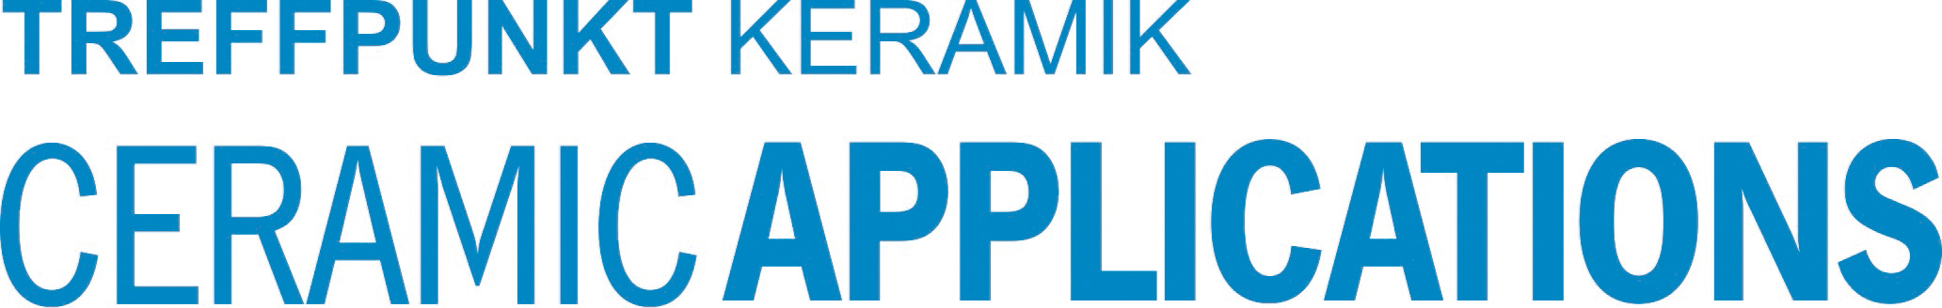

Hannover Messe, Hall 5, Stand A16

