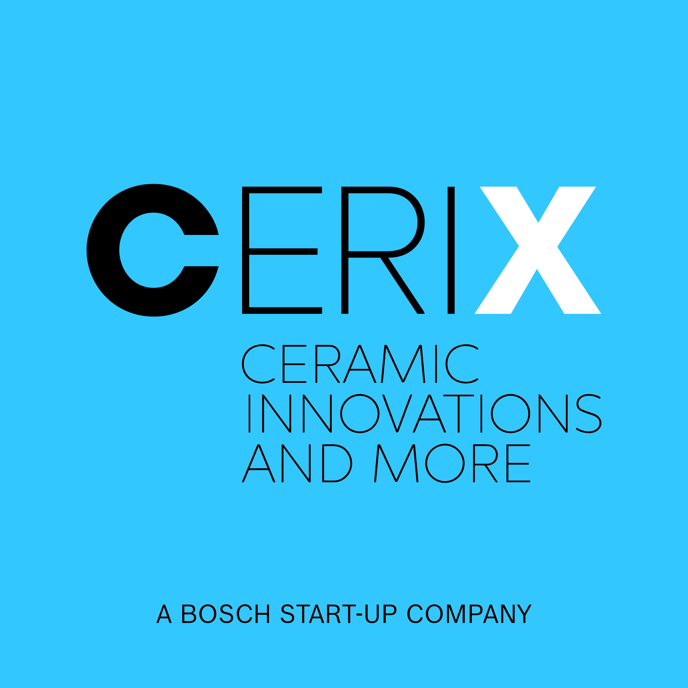

Press Release
Kempten, Germany, March 2018

CERIX – Ceramic Innovations and More

at Hannover Messe
(Hall 5 / Stand A16)

Bosch is synonymous with quality and precision in the field of high-performance ceramics for the automotive sector. CERIX, the product area ceramic of Robert Bosch Start-up GmbH is now tapping into new markets and also offering functional components made of high-tech-ceramics for consumer goods, industrial, electronically and medical engineering markets. Based on a combination of innovative manufacturing technologies and Bosch’s own material systems we develop highly innovative and precise ceramic products for the various markets.
Demands on ceramics products are continuously increasing: the maxim is to become even more complex, precise and efficient. At the interface of automation capacity, precision and complexity, Bosch (CERIX) is setting new benchmarks with innovative manufacturing technologies. Ceramic Injection Molding (CIM) in combination with inmold labelling for application of functional layers and Additive Manufacturing (3D-printing) make it possible to manufacture complex functional components with the highest degree of precision and almost unlimited geometrical design options for use in various applications – beginning from a lot size one to millions of parts.
Depending on the application, we could choose between three different materials. Zirconia, high-purity alumina and ZTA are our base materials for our CIM or 3D-printing technology.
Nevertheless, we would be pleased using additional available technologies and materials to solve your challenge. Thus we are able using our connections to the competence of the spark plug and lambda sensors business.

(1661 Characters)

Figure captions
(Cerix_1_2018-3.tif)
Optical lense carrier for laser distance measuring device

(Cerix_2_2018-3.tif)
Multiple component injection molding combined with inmold-labelling

CERIX, Iris Heibel, Iris.Heibel@de.bosch.com
CERAMIC APPLICATIONS, Karin Scharrer, k.scharrer@goeller-verlag.de

Hannover Messe, Hall 5, Stand A16

