Press Release
Baden-Baden, Germany, March 2018

CERAMIC APPLICATIONS
(Hall 5 / Stand A16)

CERAMIC APPLICATIONS is a platform, which presents the expertise of Technical Ceramics. 48 partners (40 ceramics manufacturers, each 4 equipment and material suppliers and on top 4 institutes) - with 25 German participants as well as experts from Switzerland, Austria, Portugal, the Netherlands, India, Bulgaria, Japan, USA, Spain, Great Britain and France - show innovations of the multi-faceted sector of Technical Ceramics.
The whole technology chain from raw materials, manufacturing equipment to the final products will be showcased. But the focus is on ceramic components, which offer material solutions to the various user industries especially when other materials fail (e.g. if highest abrasion and corrosion resistance of high temperature properties are needed).
Following few examples show various applications and demonstrate the wide portfolio of ceramic materials:
heat sinks for LED technology made from microstructure optimised alumina, zirconia caps for dental applications, magnesia-based crushable ceramics for nuclear fusion reactors, ceramic spacer cans for corrosion resistant pumps, SiC-bonded diamond wear parts for sub-sea applications, piezo-ceramic sensors for applications in automotive or industry 4.0, CMC components for enhanced energy efficiency in heating processes or pure transparent ceramics with mechanically, chemically, thermally, and optically superior properties.

www.ceramic-applications.com
(1473 Characters)

Press contact
CERAMIC APPLICATIONS, Karin Scharrer, k.scharrer@goeller-verlag.de

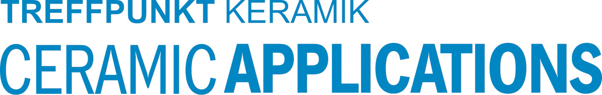

Hannover Messe, Hall 5, Stand A16

