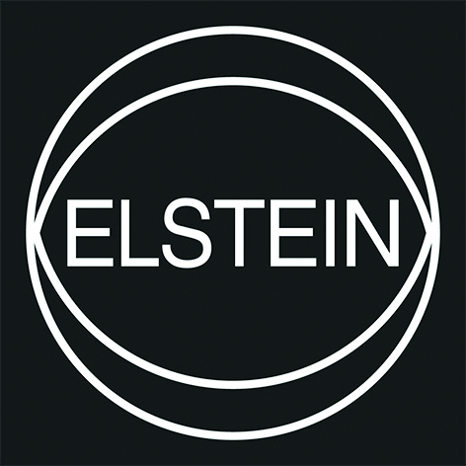

Press Release
Northeim, Germany, March 2018

Elstein: High-Efficient Heating Elements Provide Profitability for Users in Manufacturing Processes
(Hall 5 / Stand A16)

Elstein infrared heating elements have been developed and manufactured since 1950 based on own patents and production processes, in Germany. Elstein products are universally applicable and determine the state of the art worldwide.Based on the highest possible quality and performance level, Elstein products completely fulfill all expectations of OEM customers and users, regarding heating elements. The applications of Elstein heaters are nearly unlimited. They are used for example, in plastics applications, for mechanical and plant engineering, laboratory and medical technology, equipment and building technology, catering and in canteen kitchens, the food industry as well as for agricultural and animal-growing technology.

Detailed Precision
Regarding thermal engineering, reliable heating elements are of great importance. In addition, long lifetime, energy efficiency and ecological sustainability are the focus of manufacturing businesses today. Generating heat by Elstein infrared emitters brings significant advantages:
- Elstein heaters are maintenance-free and durable. In this way they contribute to the best possible avoidance of machine downtimes and associated production losses.
- Direct heating of the material: no further medium, such as air, needed for heat transfer.
- Medium to long wave infrared heaters cause direct depth heating of the material to be heated.
- No disturbing dazzle meanwhile heating process: The electrical energy is primarily used for heat production.

Most Profitable Heating
High standards: The efficiency and flexibility of production processes are going to increase. Elstein products reduce downtimes and at the same time increase the output, e.g. in terms of quantities during the manufacturing processes. It is therefore necessary for machine components such as infrared heaters, to optimally adapt these to the process requirements. Elstein products allow it through:
- Competent consultance and development, based on decades of experience.
- Fast service: direct contacts, short delivery times, worldwide product availability and assistance with technical assembly.
- Ongoing quality assurance and 100 % control of finished products.

(2294 Characters)

Press contact
Elstein-Werk GmbH & Co. KG, info@elstein.com
CERAMIC APPLICATIONS, Karin Scharrer, k.scharrer@goeller-verlag.de

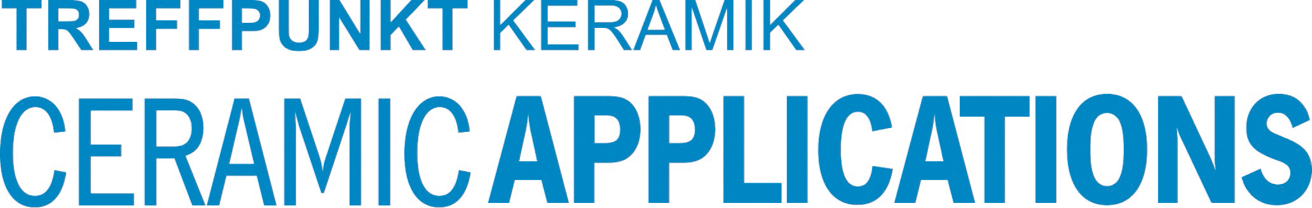

Hannover Messe, Hall 5, Stand A16

