Press Release
Izlake, Slovenia, March 2018

ETI Technical Ceramics – Reliable Supplier to the Industry
(Hall 5 / Stand A16)

ETI Technical Ceramics is a business division with more than 250 employees and a member of ETI Group, international manufacturer of electrical installation products. Since 1950, we support our customers with products and solutions based on ceramic materials. The entire range of silicate ceramic materials and alumina oxide materials are manufactured and controlled in the company in order to achieve superior material characteristics.
ETI’s modern and efficient manufacturing processes ensure high quality components suitable for many industrial markets. We are able to offer small and large quantity batches, from the single prototype component to a range of several million pieces. Most components are custom-made and developed by our engineers.
ETI Technical Ceramic components can be found in many industrial applications worldwide such as: automotive industry, electrical engineering, electronics and sensors, heating engineering, household appliances, process engineering, high temperature applications, welding applications, wear and corrosion resistance engineering and others.
Our processes follow the international standards ISO 9001:2008 and ISO 14001:2004.

(1244 Characters)

Figure captions
(ETI_1_2018-3.tif)
Ceramic powder

(ETI_2_2018-3.tif)
Dry-pressed components

Press contact
ETI Elektroelement, Dusan Jerman, dusan.jerman@eti.si
CERAMIC APPLICATIONS, Karin Scharrer, k.scharrer@goeller-verlag.de

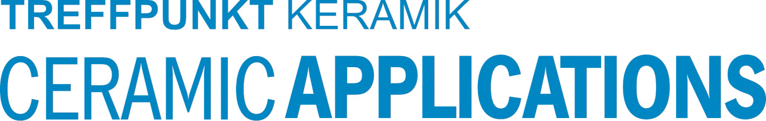

Hannover Messe, Hall 5, Stand A16

