Press Release
Höhr-Grenzhausen, Germany, March 2018

Technical Ceramics Produced by FGK
(Hall 5 / Stand A16)

The FGK sees itself as a competent partner, which can, due to a recently optimized infrastructure and an excellently trained team, rely on many years of experience in the entire field of ceramics. Divided into the R & D areas of technical ceramics, luminescent materials and optoceramics, silicate ceramics, as well as raw materials and industrial minerals, almost the entire process chain required for the development and production of ceramics can be consolidated under one roof. In addition, the FGK operates an accredited in-house testing laboratory, which can also support the activities of the project partners and customers.

Technical Ceramics
We provide you with the assistance in the development of technical ceramics for demanding applications. The demands on quality of the materials are enormous. Our wide range of knowledge and experience covers both oxide and non-oxide materials systems as well as novel ceramic composites. We are committed to the realization of your innovation. The process engineering approach of the institute forms the basis for a targeted and competent processing of high-tech tasks.

Luminescent Materials and Optoceramics
Transparent and luminescent ceramics for optical applications must meet the highest quality requirements. We develop special optical ceramics for innovative technology areas. We also deal with the development of ceramic components for photocatalytic applications.
Our know-how in the field of optoceramics and photocatalytically active components allows us to precisely adjust the optimal product properties. In accordance with your objectives and requirements, we determine the optimum parameters along the ceramic process chain.

Silicate Ceramics
With competency we are committed to comprehensive technical resources for your questions. From raw material evaluation, through process engineering to process optimization - we are happy to advise you in the field of silicate ceramics. Our close contact with the ceramic industry and its associations is of particular benefit to you. We are also happy to support you as a partner in development projects.

Raw Materials and Industrial Minerals
The selection of the right raw materials and the development of suitable raw material concepts are key to a high stability in the ceramic production process and thus also to high-quality products. Industrial minerals are used directly, without conversion of materials, and are therefore also referred to as natural raw materials. We deal with both natural and synthetic raw materials.

(2581 Characters)

Figure captions
(FGK_1_2018-3.tif)
Possible product examples of high-performance ceramics, as can be optimized and developed at FGK

(FGK_2_2018-3.tif)
Fully dense sintered, defect-free and therefore highly transparent ceramic made of highly refractive yttrium aluminum garnet

Press contact
FGK, Dr Jan Werner, jan.werner@fgk-keramik.de
CERAMIC APPLICATIONS, Karin Scharrer, k.scharrer@goeller-verlag.de

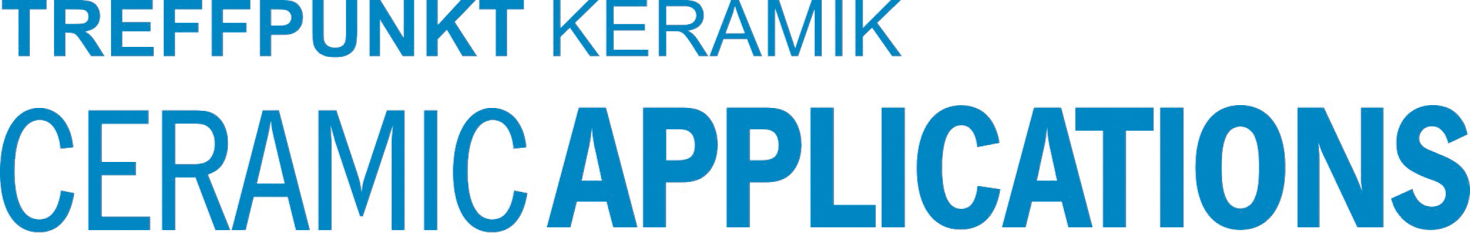

Hannover Messe, Hall 5, Stand A16

