

Press Release

Goirle, The Netherlands, March 2018

Formatec Ceramics Operates Outside the Mainstream

(Hall 5 / Stand A16)

Formatec Ceramics BV produces Technical Ceramics for a wide range of industries. We can manufacture very efficient complex ceramic components by means of Ceramic Injection Moulding (CIM). By this production process, costs decrease substantially through limitation or absence of post-processing. For prototype and small series, we offer a technical solution by combining several processes as for example 3D-printing, green machining, 5-axis-machining, grinding etc. Formatec is also involved in material and process development. We have developed Si3N4-based feedstock, electrically conductive ceramics, ESD-qualified ceramics, nickel-free cermet and components made by 3D-printing.

Ceramic materials have specific advantages such as: biocompatibility, electrically insulating or conductive, less weight than metals, wear and heat resistance.

Beside these technical advantages, some ceramic materials have also an aesthetical value being therefore used in the production of for instance watches, telephones, writing instruments and jewelry.

(1107 Characters)

**Figures**

**(Formatec_1_2018-3.tif)**

**(Formatec_2_2018-3.tif)**

**Press contact**

Formatec Ceramics B.V., Harrie Sneijers, [h.sneijers@formatec.nl](mailto:h.sneijers@formatec.nl)

CERAMIC APPLICATIONS, Karin Scharrer, k.scharrer@goeller-verlag.de

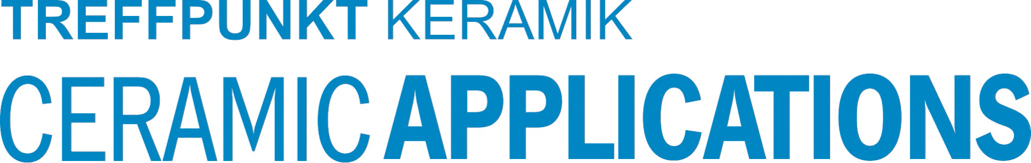

Hannover Messe**, Hall 5, Stand A16**