
Press Release
Bayreuth, Germany, March 2018

Sustainable Thermal Processes
(Hall 5 / Stand A16)

As part of the EnerTHERM project, the Fraunhofer-Center for High Temperature Materials and Design HTL is developing processes that can significantly increase the sustainability of industrial heat treatments. Initial project results will be presented at ceramitec 2018 in Munich.
Approximately 20 % of the total energy in Germany is being used for industrial heat treatment processes. If the sustainability goals set in the Paris Agreement are to be reached, drastic savings must be achieved without jeopardizing product quality.
The energy costs of the heat treatment significantly contribute to the production costs of metals and ceramics at approx. 5 - 20%. So far, the energy efficiency is far below the theoretically achievable value. The material efficiency is equally important, which can be increased by reducing scrap rates and process variations during heat treatment.
The EnerTHERM project of Fraunhofer-Center HTL aims to significantly improve sustainability in the heat treatment of materials. A comprehensive approach including process parameters, kiln furniture and heating technology is being pursued: product quality remains the top priority. At present, the ThermoOptical Measuring systems (TOM) of HTL are developed so far that a complete chemical, thermal and mechanical characterization of the high-temperature behavior of materials in a wide variety of process atmospheres is possible. In addition, methods have been set up for analyzing thermoprocessing equipment in the industry. Based on the measurement data, computer simulation methods were developed with which thermal processes can be energetically optimized without restraining the product quality. The demand for new high-temperature materials and components was derived from the analyses, and demonstrators were developed. The developments were created in close cooperation with the manufacturers and operators of thermal processing plants as well as manufacturers of high-temperature components.

(2023 Characters)

Figure captions
(Fraunhofer_HTL_1_2018-3.tif)
The EnerTHERM project is funded by the Bavarian State Ministry of Economic Affairs with EUR 9,5 million

(Fraunhofer_HTL_2_2018-3.tif)
ThermoOptical measuring system TOM_wave

Press contact
Fraunhofer HTL, Susanne Kuballa, susanne.kuballa@isc.fraunhofer.de
CERAMIC APPLICATIONS, Karin Scharrer, k.scharrer@goeller-verlag.de

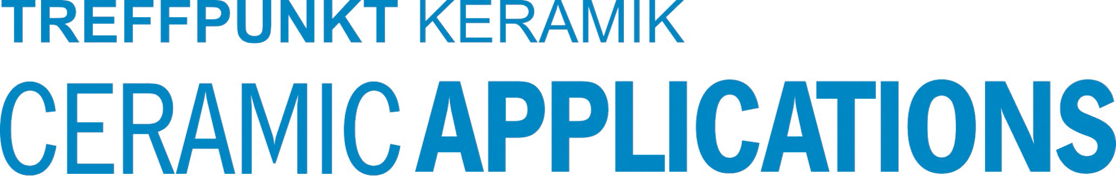

Hannover Messe, Hall 5, Stand A16

