Press Release
Blankenheim, Germany, March 2018

hightech ceram® Dr. Steinmann + Partner GmbH at Hannover Messe 2018
(Hall 5 / Stand A16)

The company hightech ceram® Dr. Steinmann + Partner GmbH was founded on 19.10.1990 and has become internationally renowned in the field of industrial ceramics with the segments engineering ceramics, high temperature ceramics and kiln furniture, high temperature insulation and wear protection. Unlike other ceramic producers, we try to adapt the properties of materials, so that they are optimally qualified for each application.
In nearly all fields we are cooperation with selected leading companies, institutes and universities. All novel know-how obtained from these key sources is immediately integrated into the production and manufacturing processes of existing and new ceramic materials and are employed in application from the beginning. The result of these efforts is that we can be proud of representing renowned companies, some of them globally active and renowned, thus fulfilling our tasks and supplementing our production range. It is our objective to open new fields of application on the basis of innovative materials and ideas, to expand them and to work out satisfying solutions in close cooperation with our customers. In the process and besides the application of standard materials and standard solutions, new approaches are made and, if necessary, materials adapted to fit each individual special requirement in the best possible way.
Wherever other materials reach their limits or do not bring the desired success, our ceramics can do the job. The application areas are versatile, whether in mechanical and apparatus engineering, brazing, soldering, and welding technique, electrical engineering, anti-friction bearings, measuring technique and valve technique or wherever wear protection is very important. Furthermore components from our materials are used in the production and repair of kilns and furnaces as well as kiln furnitures where other products are fired and sintered. Ceramics from hightech ceram® are even circulating around the world in the space-lab.
In order to produce components from optimal materials, basic knowledge about ceramics will not do. Without well-founded knowledge of the applications, for which the ceramic is intended, there will be no good results. Whether development, prototypes or serial production are concerned, we are always ready to become active for you. Most of our customers are from Europe, but we supply also to the Middle East, Asia as well as North and South America.

(2527 Characters)

Figure captions
(hightech_ceram_1_2018-3.tif)
Conveyor roller made of GPSN

(hightech_ceram_2_2018-3.tif)
Radial and axial bearing made of SSiC

Press contact
hightech ceram® Dr. Steinmann + Partner GmbH, Dr Detlef Steinmann, info@hightech-ceram.de
CERAMIC APPLICATIONS, Karin Scharrer, k.scharrer@goeller-verlag.de

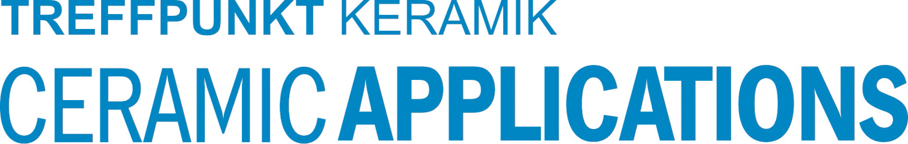
Hannover Messe, Hall 5, Stand A16

