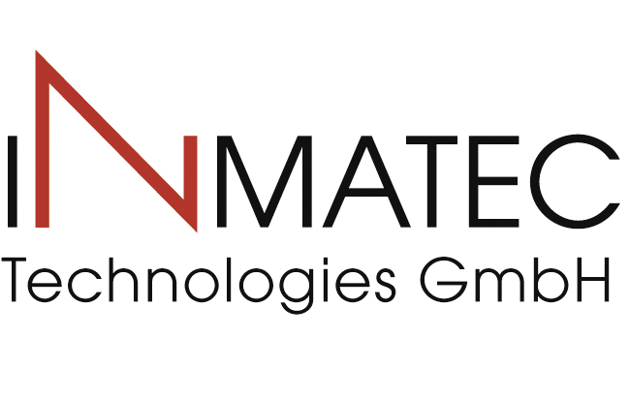
Press Release
Rheinbach, Germany, March 2018

INMATEC at Hannover Messe 2018
(Hall 5 / Stand A16)

INMATEC Technologies GmbH is the world's leading developer and producer of feedstocks for the ceramic injection molding process. Besides a great range of standard und customer-specific feedstocks based on different ceramic powders the company now is able to rely on the use of three binder systems which can be combined with the different powders. The appropriate polymer selection is usually made along the component geometry resp. conditions set by the customers.
In future the well-known INMAFEED feedstocks that are based on the Embemould-binder system (which is commercially available) will be supplemented by the INMAFLO-W and the INMAPOM-feedstocks.
Those binder systems have different characteristics regarding the injection moulding process, the green part strength and the binder removal. The target of the supplement is to open a wider parameter window for the customer and to be able to respond to potentially already existing equipment.
The INMAFEED binder system is based on a wax-polymer mixture. It is already established to the market and well-proved. The debinding process of this environmental friendly material occurs in two steps: water extraction and thermal debinding.
The INMAFLOW binder system is based on a polyamide mixture. For this material the processing temperatures during injection are low and the INMAFLOW-based feedstocks show a lower viscosity. This debinding process as well occurs in two steps: in acetone and thermal. The times of debinding are significantly shorter than for the INMAFEED-feedstocks.
The INMAPOM binder system that just recently has been brought to the market is based on polyacetal (POM) mixtures. Parts made with INMAPOM-based feedstocks show high green part strength. The binder is removed in one step by a catalytic debinding process in a nitric acid atmosphere which is the reason for a low time need.
Choosing the perfect binder system for your product the sales team of INMATEC Technologies GmbH will be glad to support you.

(2038 Characters)

Figure captions
(INMATEC_1_2018-3.tif)
Ceramic feedstock

(INMATEC_2_2018-3.tif)
Company building in Rheinbach

Press contact
INMATEC Technologies GmbH, Karin Hajek, karin.hajek@inmatec-gmbh.com
CERAMIC APPLICATIONS, Karin Scharrer, k.scharrer@goeller-verlag.de

Hannover Messe, Hall 5, Stand A16

