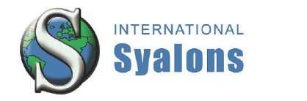

Press Release
Wallsend, Great Britain, March 2018

International Syalons to Exhibit at Hannover Messe 2018
(Hall 5 / Stand A16)

International Syalons (Newcastle) Ltd. are the GB’s leading manufacturer of SiAlON and silicon nitride based ceramic products and powders, with nearly forty years’ experience in the production and development of advanced engineering ceramics.
Based in the North East of England, International Syalons offer custom, high quality, advanced ceramic solutions for a wide range of demanding engineering applications through materials such as silicon nitride (Si₃N₄), zirconia (ZrO₂), alumina (Al₂O₃), and silicon carbide (SiC).
International Syalons are committed to providing world class fine ceramic solutions to meet your industrial materials requirements. Our silicon nitride and sialon ceramics offer wear, corrosion and thermal resistance and are available for example as ceramic tubes, thermocouple sheaths, weld pins, weld rolls, extrusion dies, wear liners, and foundry products.
Our products are world-renowned within the non-ferrous molten metal industry, as well as metal forming, welding, chemical processing, oil and gas, wear, automotive and aerospace industries. In addition, our R & D department, in collaboration with world renowned Institutes and Universities, are continuing to develop new materials, composites and cutting-edge fabrication processes to ensure our customers are getting the best advanced silicon nitride ceramics available.
Visit International Syalons at the ceramitec 2018 exhibition in Hall B6, Stand 321/420. For more information, visit syalons.com, E-mail enquiries@syalons.com, or call +44 (0)191 2951010.

(1615 Characters)

Figures
(Industrial_Syalons_1_2018-3.tif)

(Industrial_Syalons_2_2018-3.tif)

Press contact
International Syalons, Ben Melrose, ben.melrose@syalons.com
CERAMIC APPLICATIONS, Karin Scharrer, k.scharrer@goeller-verlag.de

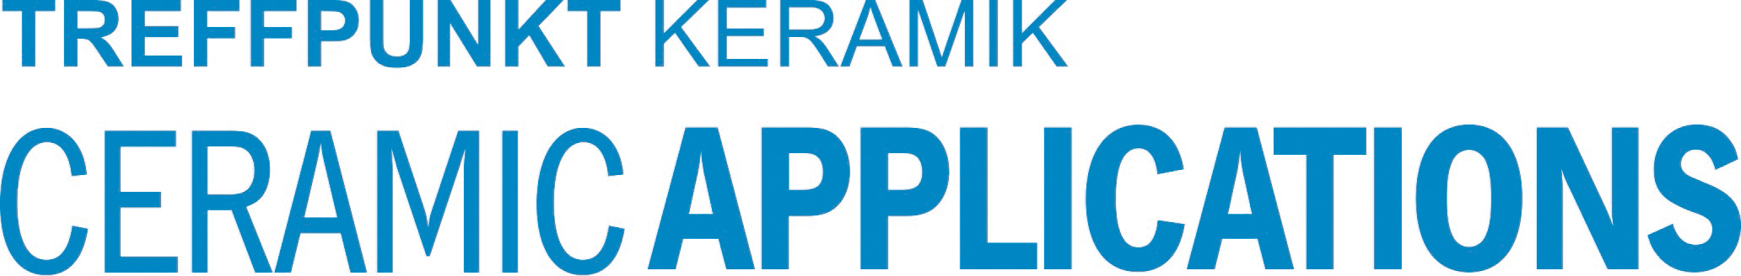

Hannover Messe, Hall 5, Stand A16

