Press Release
Kaiserslautern, Germany, March 2018

LOOMIS PRODUCTS Kahlefeld GmbH – Isostatic Dry Bag Presses, Isostatic Wet Bag Presses, Piston Extrusion Presses Manufactured in Kaiserslautern, Germany
(Hall 5 / Stand A16)

LOOMIS PRODUCTS produces piston extrusion presses (extruders) and isostatic wet and dry bag presses (high pressure - powder compression systems) for the ceramic, metal, refractory, stoneware, and PTFE powder industry’s.
Our complete product portfolio is sold, developed, manufactured, tested, installed and serviced by our company’s personnel. By doing so, we deliver quality equipment, on time, to our customers, worldwide.
As leaders in the industry for cold isostatic presses and piston extrusion presses, it is our goal to use our knowhow to specifically design and optimized equipment to each customers requirement’s. Placing a high level of importance on developing and delivering systems to our customers, which improve their manufacturing process as well as ease the use of the system for the operator and maintenance personnel. It is of great importance to us, for you to know, that we can also develop peripheral automated systems for your new press lines or for existing processes, optimizeing our customers manufacture so he can deliver quality products, saving our customers time and money.
Our last new development - released in 2016 - the LOOMIS-SiCo-Rheopress® is a revolution regarding the sector of analysis of materials and their flow characteristics. With the aid of this machine, you can gather information, to help in the optimization and design of powder compacting extrusion tools and test the quality of the material composition you are pressing, in a very short time.
In 2018 LOOMIS PRODUCTS is in the process of developing a pressing system for testing and small production of materials/parts.
Are you curious now? We hope so. Come back and check on our progress periodically in the coming year. Visit us at www.loomis-gmbh.de!

(1921 Characters)

Figure captions
(Loomis_1_2018-3.tif)
Isostatic wet bag press

(Loomis_2_2018-3.tif)
Piston extrusion press

LOOMIS PRODUCTS Kahlefeld GmbH, Marc Jahn, Marc.Jahn@loomis-gmbh.de
CERAMIC APPLICATIONS, Karin Scharrer, k.scharrer@goeller-verlag.de

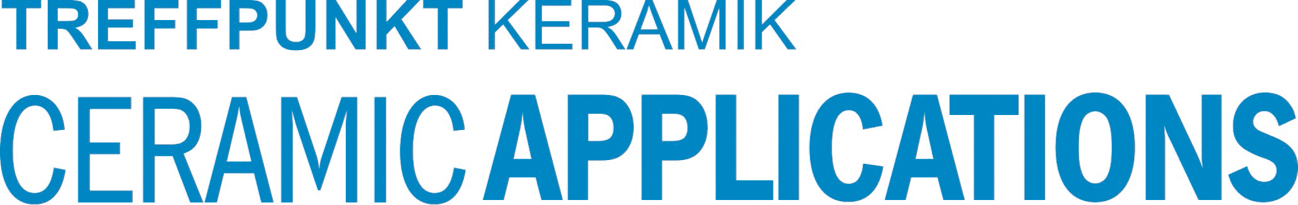

Hannover Messe, Hall 5, Stand A16

