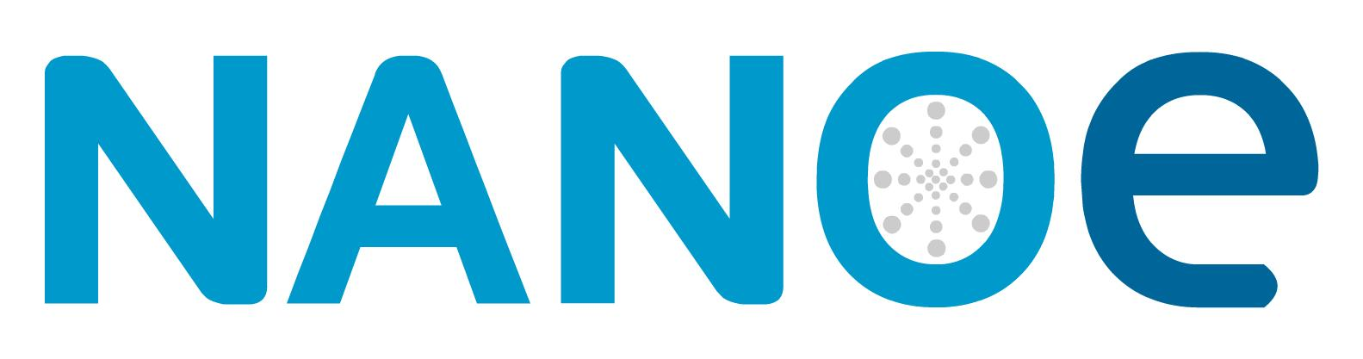

Press Release
Ballainvilliers, France, March 2018

Nanoe Launches Alumix® – a New Ceramic
3D-Printing Filament
(Hall 5 / Stand A16)

Following its strategy to develop new raw materials for ceramic 3D-printing, Nanoe is launching Alumix®, a filament for Ceramic Filament Manufacturing (CFM). Alumix is a filament constituted of a polymer matrix and an alumina powder, which can be used in any fused deposition modeling 3D-printer. The 3D-printed shape is afterwards debinded and sintered in the same processes as Ceramic Injection Molding (CIM).
“We see exiting possibilities for Alumix®” says Guillaume de Calan, CEO of Nanoe. “CFM is a very affordable way to make ceramic 3D-printed parts. With an investment of less than EUR 2000 in a 3D-printing machine, our customers will be able to start producing some parts, and learn to use this technology. First application will be prototyping of ceramic parts for our customers, especially those using CIM. We also see possibilities to produce unique parts for industrial applications, wear parts, medical and jewelry.”
Nanoe will offer a starter pack for CFM. The pack will include the 3D printer, some filament spools to get started, and training. The purpose of the training will be to help our customers new to this additive process to get the hang of it. The technology might look very simple, but as for any shaping process, there is a lot to learn before being able to use it in production. This is why the training will include courses both on the software and the material side. Debinding and sintering in particular are key points to achieve high density ceramic pieces without any cracks or deformation.
Alumix® will be launched at ceramitec and Ceramics Expo, in Cleveland/US, for preorders. First expected deliveries will take place in September. Nanoe will also offer very soon filaments based on zirconia (Zircomix®) and ZTA (Zetamix®). Prospects for Nanoe are to find industrial partnerships with additive manufacturing companies. The goals will be to adapt the printers to this new application, and to develop new raw materials compatible with their existing processes.

(2078 Characters)

Figure
(Nanoe_1_2018-3.tif)

Press contact
Nanoe, Hugues Roullier, h.roullier@nanoe.com
CERAMIC APPLICATIONS, Karin Scharrer, k.scharrer@goeller-verlag.de

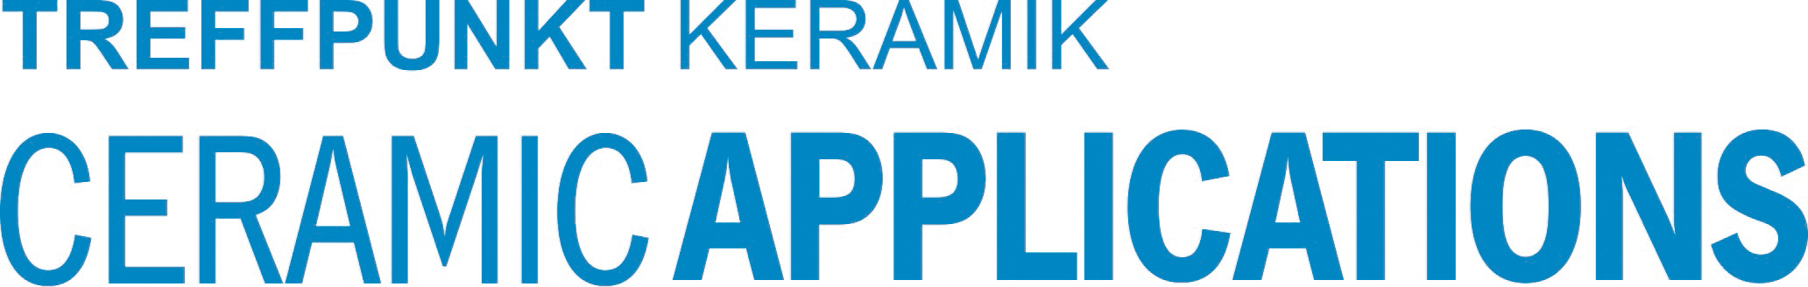

Hannover Messe, Hall 5, Stand A16

