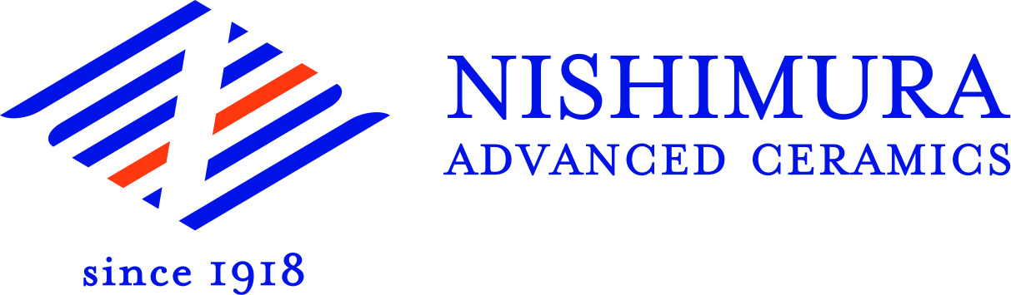
Press Release
Kyoto City, Japan, March 2018

Professional Advanced Ceramics Producer from Japan
(Hall 5 / Stand A16)

Since its foundation in 1918, Nishimura Advanced Ceramics has been offering best solutions for 100 years employing its ceramic manufacturing know-how to design and develop products and raw materials. Nishimura Advanced Ceramics does not only process ceramic materials, the company is also an integrated ceramics manufacturer by kneading and spray-drying ceramic raw materials, shape, fire and process them to finished products, even for an order of only one item.
Nishimura Advanced Ceramics’s specialty is the material improvement by R&D focused on material development, especially small crystallization. Nishimura’s unique materials such as N-9000NS alumina ceramic with a purity of 99,99 % and a crystal size of 1-3 µm as well as its N-9H ceramic heat sink are results of this activity. The company produces not only alumina-based materials, but also materials based on zirconia, aluminum nitride, aluminum titanate, yttria, porous alumina, forsterite, zircon, cordierite, etc. Therefore, the user industries are a wide range as for example semiconductors, medical technology, mechanical industry, heat sinks, electronics, etc.
Nishimura Advanced Ceramics is widely open for any industry, material and design.
(1281 Characters)

Figure captions
(Nishimura_1_2018-3.tif)
N-9000NS SEM picture

(Nishimura_2_2018-3.tif)
Pioneer of CIM

Press contact
Nishimura Advanced Ceramics, Ko Nishimura, npc-e3@nishimuratougyou.co.jp
CERAMIC APPLICATIONS, Karin Scharrer, k.scharrer@goeller-verlag.de

Hannover Messe, Hall 5, Stand A16

