
Press Release
Hochdorf, Germany, March 2018

Tailored High Performance Ceramics
(Hall 5 / Stand A16)

OxiMaTec’s ceramic formulations are not standard grade materials. Its material formulations are tailored with repect to the application. As an example, dental implants made by injection moulding with filigree geometrical design are based on injection moulding granules with nano-scaled particles, while milling and drilling tools have to be tough and stable at high temperatures. Such an approach requires deep knowledge of material knowledge and powder technology, in order to define the processing chain.

Due to their unique material properties, high performance ceramics become more and more important for new applications. For people, who show allergic reactions with metals, dental implants based on ceramics eliminate such reactions and their excellent biocompatibility overcomes such negative impacts. In order to realize filigree parts with inner holes and windings, OxiMaTec has developed a material formulation for ceramic injection moulding, which is based on nano-scaled powders. Since yttria-stabilized zirconia materials are already qualified for medical applications, this new material is based on this material system. However, opposite to the materials available on the market, OxiMaTec has developed the so-called coating process, which finally shows a higher hydrothermal stability compared to standard materials.
The mean particle size of nano-scaled powders is about 80 – 100 nm with a specific surface area of 17,5 m²/g, while standard grade materials have a surface area of about 8 m²/g and particle size between 300 – 500 nm. Such a fine grained powder cannot be handled by conventional forming technologies. Therefore an injection moulding process has been developed, which allows to make defect-free parts under economic conditions without machining after the sintering process.
Totally different requirements are mandatory for milling and drilling tools, i.e. trimming operations in fibre reinforced plastics for aerospace applications. OxiMaTec has developed a new material formulation, which combines high hardness, strength and fracture toughness as well as high temperature stability. Such new ceramic tools have a longer life-time compared to carbide-based tools. Furthermore, such tools do not show any chemical reactions with the work-piece, which besides its economic advantages also have fail save running functions.
These new cutting tools are based on an alumina matrix with dispersed zirconia and hexagonal platelets therein. Within the material formulation, a very special “bridging” between alumina and zirconia is applied in order to strengthen the microstructure further. Its low weight allows extremely high spindle speed without stresses in the bearings. Special geometrical designs have been developed for optimizing the milling and drilling parameters, which are different from well-known designs of tungsten carbide tools. Cherry-tools have been qualified for milling graphite.
In order to achieve reproducible precise parts, OxiMaTec cares for the whole processing chain. Only raw materials, which are based on chemically derived processes, are used. These powders are characterized and for making homogeneous mixtures it is mandatory to understand the colloidal chemistry. No commercially available dispersing agents are used; all suspensions are based on defined chemical compositions. Milling, spray-drying, plasticization, pressing, injection moulding, de-binding and sintering are made in-house by a severe control of all processing steps. Each individual material formulation has its own procedure and inspection plan. Due to the excellent analytical laboratory, all inspections required are made in-house.

(3711 Characters)

Figure captions
(Oximatec_1_2018-3.tif)
Two-piece dental implant

(Oximatec_2_2018-3.tif)
Ceramic cutting tools for processing fiber-reinforced plastics or graphite

Press contact
OxiMaTec GmbH, Dr Wolfgang Burger, info@oximatec.de
CERAMIC APPLICATIONS, Karin Scharrer, k.scharrer@goeller-verlag.de

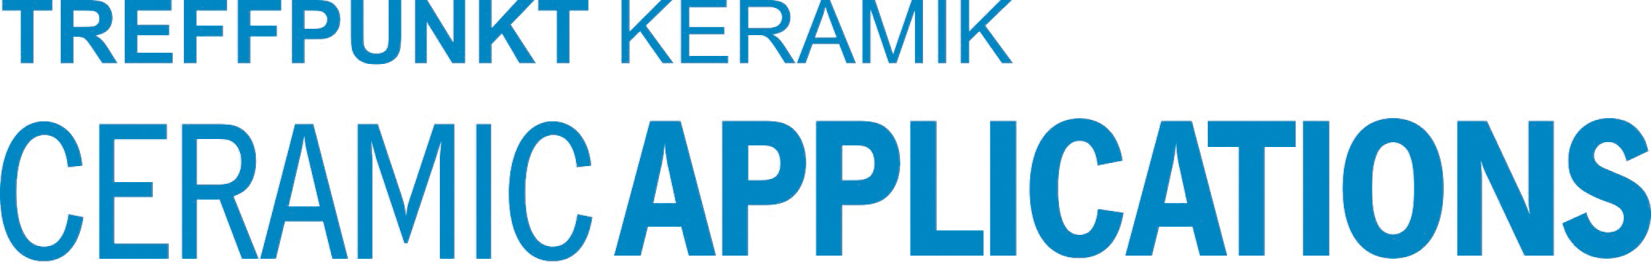
Hannover Messe, Hall 5, Stand A16

