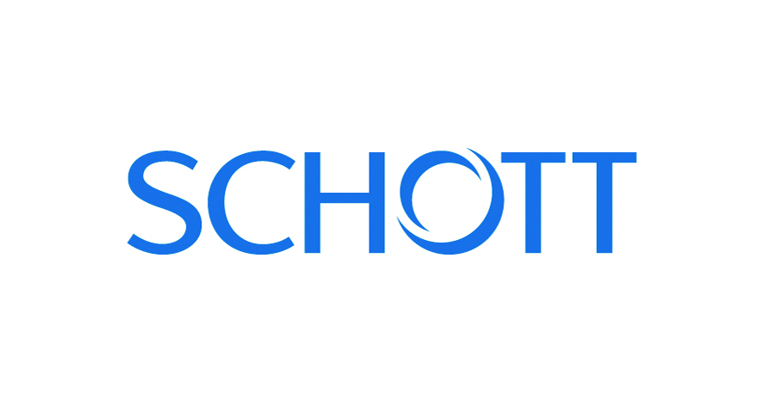

Press Release
Hannover/Mainz, Germany March 2018

Glass-Ceramics as a Catalyst for Product Design
(Hall 5 / Stand A16)

Transparent, robust and esthetic: SCHOTT’s NEXTREMA® glass-ceramics are on target to impress visitors during the 2018 edition of Hannover Messe with material ideas to inspire special product designs. High-tech glass-ceramics from SCHOTT NEXTREMA® exceed when established materials such as plastic, conventional glass or metal have reached their limits. At this year’s Hannover Messe, the international technology group SCHOTT will be showcasing the material’s entire portfolio as well as its depth of applications – from transparent electrical appliances and attractive heating units to interactive whiteboards for the office.

NEXTREMA® glass-ceramics have shown their versatility in providing plenty of room for creativity and what can be realized when working with them. Visitors to SCHOTT‘s exhibition can watch the bread in a Morphy Richards toaster turn golden brown thanks to the appliance’s glass-ceramic panels. Using the robust material, the British home appliance manufacturer has also developed an iron with a see-through sole. In addition, the glass-ceramics manufacturer has also made quite an impression with its infrared heating units for outdoor areas in the food services industry or for private terraces. “For product development, we collaborate with companies from a number of industries such as chemical, mechanical engineering and consumer electronics,” notes SCHOTT product manager Roberto Perez Castro.
Robust glass-ceramics for a vast array of applications
Without a doubt, the special properties of what SCHOTT calls its “next extreme material” go a long way in explaining the reasons behind its success. NEXTREMA® has been developed to withstand temperatures up to 950 °C not to mention rapid temperature changes. Glass-ceramic is ideal when used in the infrared area of an appliance such as a radiant heating unit where it can significantly reduce the emission of harsh light while ensuring maximum thermal output. As a viewing window in gas grills or as a cover for gas burners, the material can withstand wide temperature variations such as the heat held within the interior of a device and the winter cold of an outdoor environment.
Yet, the transparent high-tech material also has a smooth, non-porous surface, which allows for the development of multi-functional concepts. For the latest in office and workspace design, SCHOTT has developed an elegant whiteboard made from opaque white glass-ceramic. When used as a blackboard, it is not only easy to write on, but also to clean. As an interactive screen, the imaging surface is perfect for digital projections. And with a rear panel made of metal, the board can act as a magnet with metallic objects adhering to it.
“Because we place a great deal of value in allowing the highest level of design freedom possible, we offer NEXTREMA® in six colorful material options: from transparent or translucent white, to blue-grey or black or even opaque white or grey,” explains Roberto Perez Castro. Finally, glass- ceramics are well suited when it comes to the forming process, allowing designers full flexibility in creating esthetically pleasing, bent variations of a particular product.
NEXTREMA® is a registered trademark of SCHOTT AG.

(3275 Characters)

Figure captions
(Schott_1_2018-3.tif)
NEXTREMA® is available in various forms and colors

(Schott_2_2018-3.tif)
Thanks to the material‘s features, NEXTREMA® will be a welcome alternative for generating new product ideas and innovations

Press contact
SCHOTT AG, Michael Müller, michael-matthias.mueller@schott.com
CERAMIC APPLICATIONS, Karin Scharrer, k.scharrer@goeller-verlag.de

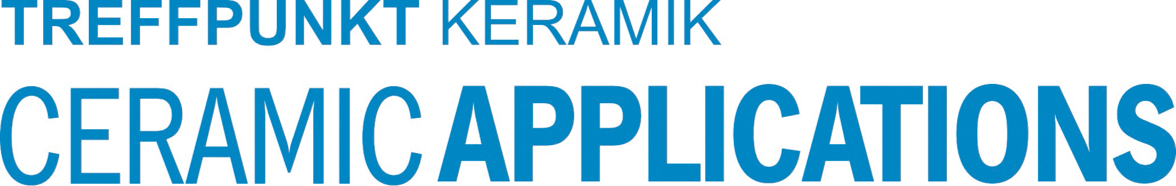

Hannover Messe, Hall 5, Stand A16

