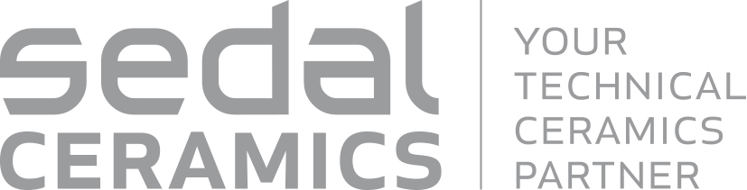
Press Release
Barcelona, Spain, March 2018

Sedal Ceramics – Your Technical Ceramics Partner
(Hall 5 / Stand A16)

Sedal Ceramics is the TECHNICAL CERAMICS Division of Sedal Group. The company is focused on the design, manufacture and sale of ceramic components for electronics, energy and automotive, as well as for the industrial machinery, chemical, food industry and sanitary sectors.
It is a worldwide operating ceramic components provider with customers in 4 continents and within its facilities
is producing millions of pieces complying with the highest international quality standards.
The long term cooperation with companies around the globe is the key of our success, with a strong focus on becoming your preferred partner.
Taking advantage of decades manufacturing experience and as a result of our R&D activity, Sedal Ceramics has developed, in addition to other materials, SEDALOX, our own alumina composition with Nano Shelter Technology, which offers outstanding performance to every single product we manufacture. Starting from raw material, our fully integrated manufacturing process and state-of-the-art facilities guarantee the best results to the most demanding customers.
During 23–27 April, Sedal Ceramics is exhibiting at Hannover Messe 2018. Discover its technical advanced products in hall 5, stand A16.
(1280 Characters)

Figure captions
(Sedal_1_2018-3.tif)
Sedal Ceramics products

(Sedal_2_2018-3.tif)
Sensor application

Press contact
Sedal Ceramics, Joaquín Vega, j.vega@sedal.com
CERAMIC APPLICATIONS, Karin Scharrer, k.scharrer@goeller-verlag.de

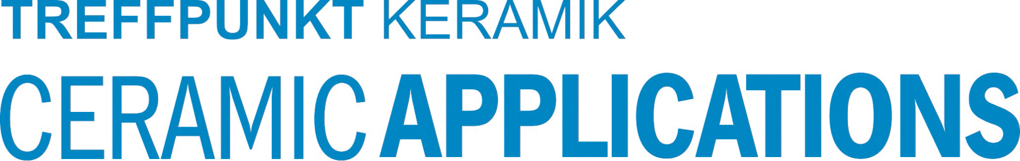
Hannover Messe, Hall 5, Stand A16

