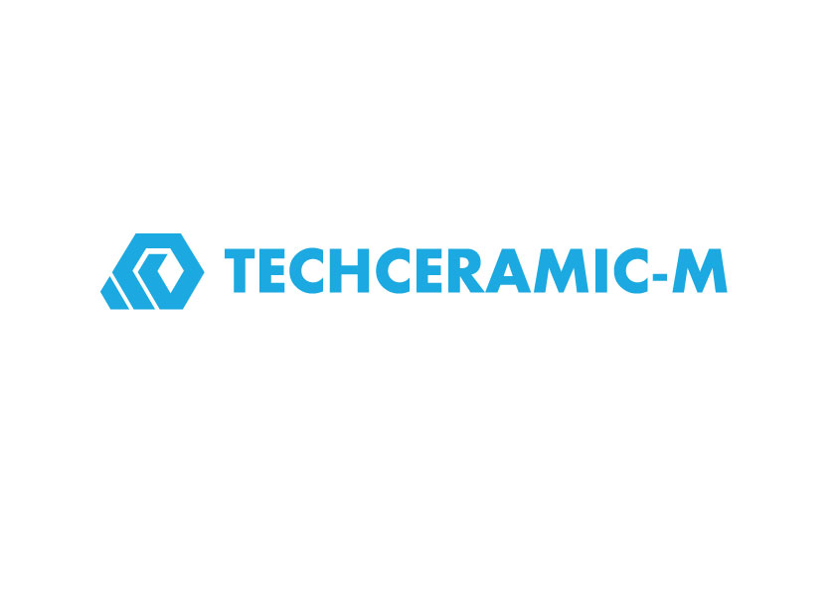
Press Release
Mezdra, Bulgaria, March 2018

Techceramic-M at Hannover Messe 2018
(Hall 5 / Stand A16)

Techceramic-M is developer, manufacturer and worldwide supplier of ceramic components with a broad and ever growing range of applications that meet the ISO 9001-2008 accredited quality management system. Ceramic components are widely used in automotive casting, mechanical, petrochemical, electrical, electronics, and textile industries. In 1999 Techceramic-M developed aluminium titanate ceramic components. Its excellent test results set the company to become one of the world’s largest producers of aluminium titanate ceramic products. With high educated employees, the company´s production lines are managed and supervised by high level technicians, machinists and mechanical engineers. Our company has very strong R&D team of ceramic engineers.
Our advantages are custom-made ceramic components with precise tolerances while delivering a significant number of cost cutting benefits over more mainstream materials. We increased our capacity, range of products and applications. Priority activities of the company are international markets. Exports reached 99 % of total production in the European Union, North America, Middle East and Asia.

The product range consists of:
Foundry products made of aluminium titanate: riser tubes, dosing tubes, sprue bushings, spouts, and fill tubes; Insulating products: intermediate tubes, and baffle plates; Cast-house products: vacuum-formed products made of ceramic fibers; Products made of high purity refractory materials, insulating fire elements, special refractory bricks, as well as tubes for heaters and kiln furniture.

(1621 Characters)

Figure caption
(Techceramic_1_2018-3.tif)
Techceramic`s products

Press contact
Techceramic-M Ltd., Preslav Hristov, office@techceramic-m.com
CERAMIC APPLICATIONS, Karin Scharrer, k.scharrer@goeller-verlag.de

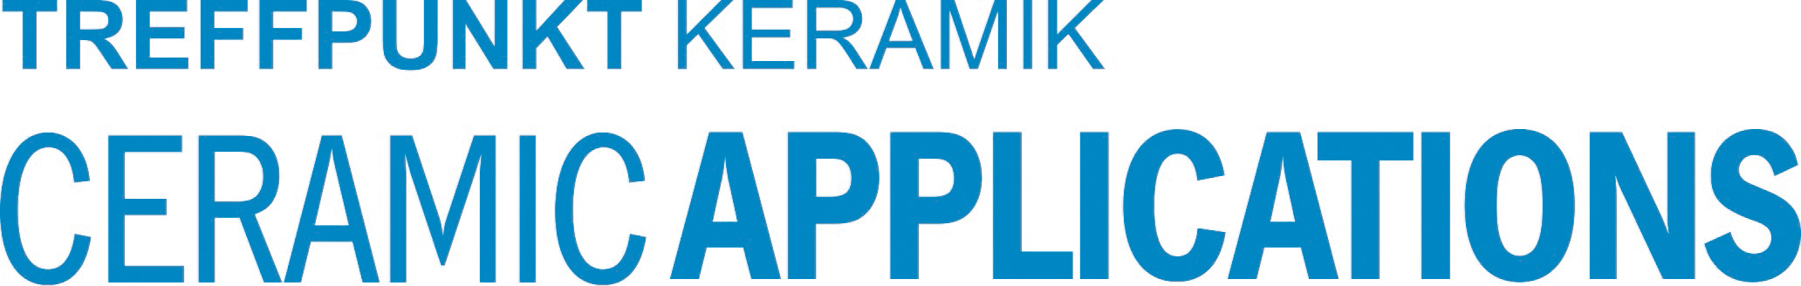

Hannover Messe, Hall 5, Stand A16

