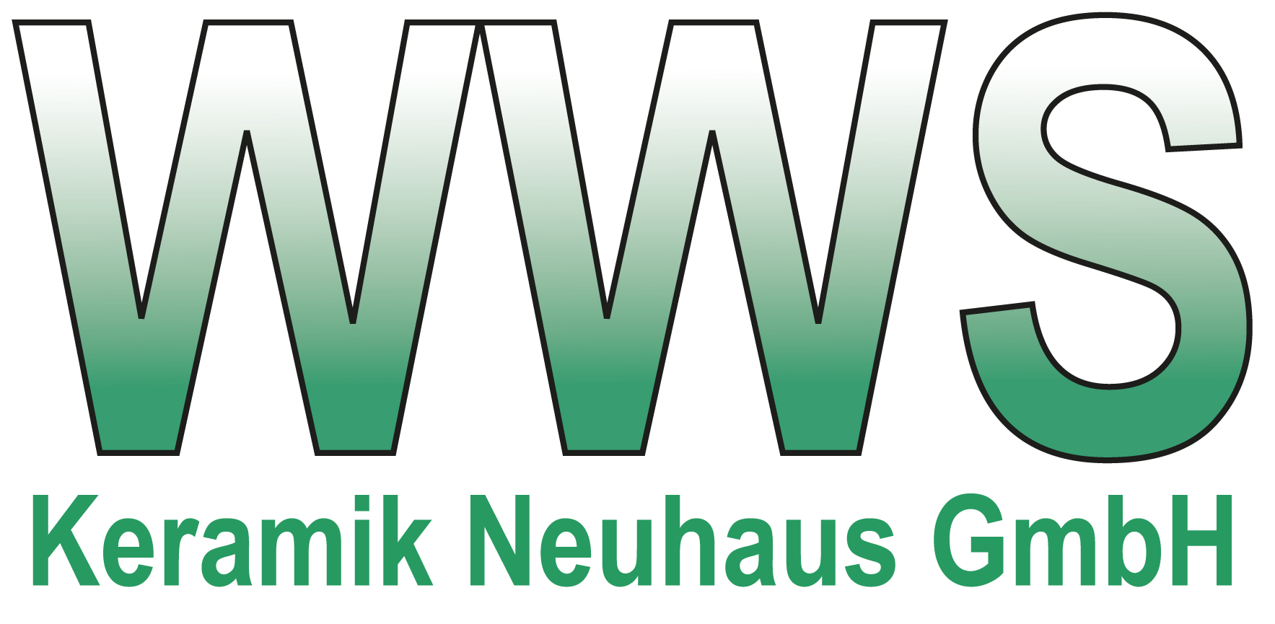
Press Release
Neuhaus-Schierschnitz, Germany, March 2018

WWS Keramik Neuhaus GmbH – Traditional and Innovative
(Hall 5 / Stand A16)

Since 1993, WWS Keramik Neuhaus GmbH prides itself in continuing a 115 year presence of Technical Ceramics in the industrial area of Neuhaus-Schierschnitz in the district of Sonneberg, South Thuringia. With an abundance of long-standing experience and solid, technical skills we produce electro-ceramic products for the low-voltage industry. While the different manufacturing processes allow for mostly small to medium sized production quantities, minimal quantities of unique and individual customer design and order-specific productions are just as feasible. Our various range of ceramic materials include C 111, C 130, C 221, C 410, C 520, C 530, C 610, C 620.

The two production processes divide into dry press and extrusion. The form, size, quantity and required accuracy of the desired product are determining factors for the manufacturing process.
The dry press process involves the usage of hydraulic presses where pressure of up to 100 t is being reached. With the extrusion process tubes, rods and other profiles are drawn out to a length of 1100 mm and a diameter of min. 2 mm to max. 125 mm. Numerous products are prepared mechanically (cutting, drilling, milling, turning and deburring) according to technical specifications before the sintering process takes place. A glazing can be applied if necessary or desired.

Our products include insulators for electric fuses, bolt terminals (mounted and unmounted) in accordance with DIN 46260 and DIN 46262, terminal block and clamp board connections (mounted and unmounted) for electrical connections, sleeves and counter pieces, insulating elements for electrical resistors, ceramic isolation pearls, grooving isolators, insulation for high voltage terminals, ceramic tubes and rods (glazed and unglazed) with different inner and outer profiles as well as various specialized products.

The areas of application are widely spread and range from the manufacture of fuses, switches, controllers, transformers und furnaces to mechanical-, electrical-, electronic-, medical-, heat and apparatus engineering and furthermore cover household equipment, metrology, electromotive-, automotive and heating industry.

In November 2017 WWS Keramik Neuhaus GmbH won the XX. Thüringer Innovationspreis (the highest innovation award in Thuringia) for the category tradition and future. Herewith the longstanding experience with technical ceramics was combined to develop ceramic grill rods. These will give a completely new grilling experience to the commercial consumer. You can find further information about this patented invention on www.keraking-grill.de.

With a highly motivated team, extensive and comprehensive expert knowledge and innovative thinking WWS Keramik Neuhaus GmbH meets the most challenging demands of the ceramic industry.

(2860 Characters)

Figure captions
(WWS_1_2018-3.tif)
Products manufactured by WWS Keramik

(WWS_2_2018-3.tif)
Small grill

Press contact
WWS Keramik Neuhaus GmbH, Dipl.-Kfm. Holger Kuhna, holger.kuhna@wws-keramik.de
CERAMIC APPLICATIONS, Karin Scharrer, k.scharrer@goeller-verlag.de

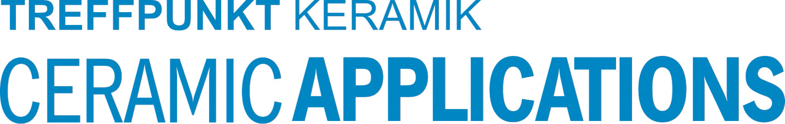
Hannover Messe, Hall 5, Stand A16

